Review Kahoots for Unit 3

Use this pic for Mission 6 Review questions 1-4: 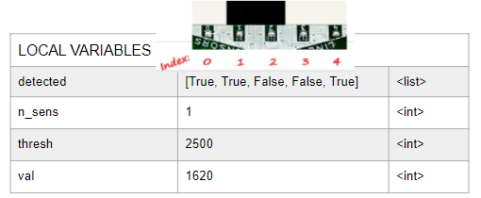
Mission 6 - Line Follower
What is the value of detected[2]? | - True  - False  - 0  - 1
What is the value of detected[n_sens] | - True  - False  - 0  - 1
What is the final value of n_sens?  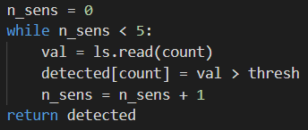 | - 4  - 5  - [True, True, False, False, True]  - True
For n_sens, val < thresh returns True. What type of line is it detecting? | - White line on dark ground  - Black line on light ground  - Not enough information  - Could be either one
If the ‘bot’s sensors 1 and 2 are detecting a line, what is the value of “detected”? | - detected = [False, False, False, False, False]  - detected = [True, True, True, True, True]  - detected = [False, True, True, False, False]  - detected = [True, False, False, True, True]
What is the data type:  x = 5 | - int  - float  - list  - tuple
What is the data type:  x = (0, 1, 1, 0, 0) | - int  - float  - list  - tuple
What is the data type:  x = [True, True, True, False, False] | - int  - float  - list  - tuple
What is the data type:  x = 1.245 | - int  - float  - list  - tuple
What code accesses a single value from a list or tuple? | - vals  - vals = (0, 1, 1, 0, 0)  - vals[3]  - vals(3)
What will be printed on the console?  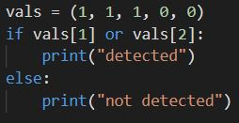 | - An error occurs  - detected  - not detected  - detected followed by not detected
What does the highlighted code do?  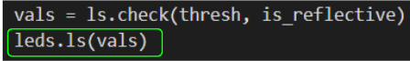 | - Uses the tuple “vals” to turn on or off line sensor LEDS  - Turns on the one LED at index “vals”  - Assigns a True value to “vals” for each LED that is currently on  - Causes an error
What is the value of x?  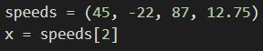 | - 45  - -22  - 87  - 12.75
What is the value of x?  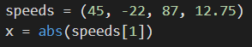 | - 45  - 22  - -45  - -22
What is the value of x?  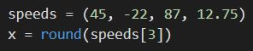 | - 87  - 12.75  - 12  - 13

Mission 7 - Hot Pursuit
What is returned by the function prox.detect() | - Either True or False  - A tuple of two Boolean values  - A tuple of 0 and 1  - An integer between 0 and 4095
LEFT is assigned what value? | - True  - 0  - 1  - False
What are the settings of the “power” parameter of prox.detect()? | - 1-8  - 0-7  - 1-100  - True or False
What are the settings of the “threshold” parameter of prox.detect()? | - 1-8  - 0-7  - 1-100  - True or False
What is the purpose of prox.range()? | - Determine if an object is in front of the ‘bot  - Move the ‘bot a specified distance  - Determine the lowest power needed to detect a reflection  - Determine the lowest threshold where a reflection is detected
What does prox.range() return? | - A tuple with the values True or False  - A tuple with two integers, up to 100  - True or False  - The best range for both sensors
If prox.range() doesn’t detect any reflection, what does it return? | - False  - 0  - (-1, -1)  - (False, False)
What is the final value of det?  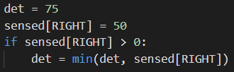 | - 75  - 50  - 0  - True
What line of code is needed when updating a global variable in a function? | - global thresh  - local thresh  - thresh = 0  - update thresh
What is the smallest value that can be assigned to “power”?  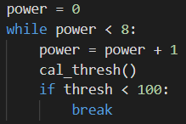 | - 0  - 1  - 8  - 100
What is the highest value that can be assigned to “power”? | - 0  - 1  - 8  - 100
When will the loop end? | - When power == 8  - When threshold < 100  - When either power ==8 or threshold < 100  - Won’t end, infinite loop
What is the final value of go_motors?  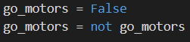 | - False  - True  - No  - An error occurs
About how long does it take for the code to read prox.detect() 100 times? | - 1/10 seconds  - 10 seconds  - 100 seconds  - 1 second
What are the possible values for “turn_ratio”? | - True and False  - 0-1  - All numbers between -1 and 1  - All numbers between 0-100

Unit 3 Vocabulary Review/Test (Missions 6-7: “The computer science definition of …”)
(A total of 15 terms introduced in the missions, use the ones you want–same terms for review/ test)
list | - A value that is an integer  - A sequence of indexed items you can change  - A sequence of indexed items that are immutable  - A value that is a decimal
tuple | - A value that is an integer  - A sequence of indexed items you can change  - A sequence of indexed items that are immutable  - A value that is a decimal
int | - A value that is an integer  - A sequence of indexed items you can change  - A sequence of indexed items that are immutable  - A value that is a decimal
float | - A value that is an integer  - A sequence of indexed items you can change  - A sequence of indexed items that are immutable  - A value that is a decimal
or | - A logical operator that inverts the Boolean operand  - Evaluates to True only if both conditions are True  - Evaluates to True if one or both conditions are True  - A named chunk of code that accomplishes a task
not | - A logical operator that inverts the Boolean operand  - Evaluates to True only if both conditions are True  - Evaluates to True if one or both conditions are True  - A named chunk of code that accomplishes a task
function | - A logical operator that inverts the Boolean operand  - Evaluates to True only if both conditions are True  - Evaluates to True if one or both conditions are True  - A named chunk of code that accomplishes a task
Hard coded values | - Specific numbers used in code that should be constants  - Variables defined inside a function  - Variables defined outside a function in the main program  - A list of variables declared in a function definition that receive values
parameters | - Specific numbers used in code that should be constants  - Variables defined inside a function  - Variables defined outside a function in the main program  - A list of variables declared in a function definition that receive values
globals | - Specific numbers used in code that should be constants  - Variables defined inside a function  - Variables defined outside a function in the main program  - A list of variables declared in a function definition that receive values
locals | - Specific numbers used in code that should be constants  - Variables defined inside a function  - Variables defined outside a function in the main program  - A list of variables declared in a function definition that receive values
auto-calibrate | - The brightness of CodeBot’s IR flashlight  - Set the sensors to adapt to their environment by setting parameters  - How much light is needed to detect an object (from 1 to 100)  - Infrared sensors that can detect nearby objects based on reflected light
Proximity sensors | - The brightness of CodeBot’s IR flashlight  - Set the sensors to adapt to its environment by setting parameters  - How much light is needed to detect an object (from 1 to 100)  - Infrared sensors that can detect nearby objects based on reflected light
Detection sensitivity | - The brightness of CodeBot’s IR flashlight  - Set the sensors to adapt to its environment by setting parameters  - How much light is needed for to detect an object (from 1 to 100)  - Infrared sensors that detect nearby objects from reflected light
Emitter power level | - The brightness of CodeBot’s IR flashlight  - Set the sensors to adapt to its environment by setting parameters  - How much light is needed for to detect an object (from 1 to 100)  - Infrared sensors that can detect nearby objects based on reflected light

Use this pic for Mission 6 Review question 1:
Unit 3 Concepts and Coding Kahoot Review (Missions 6, 7) / (questions from 2 review kahoots)
What is the value of detected[2]? | - True  - False  - 0  - 1
What is the final value of n_sens? | - 4  - 5  - [True, True, False, False, True]  - True
If the ‘bot’s sensors 1 and 2 are detecting a line, what is the value of “detected”? | - detected = [False, False, False, False, False]  - detected = [True, True, True, True, True]  - detected = [False, True, True, False, False]  - detected = [True, False, False, True, True]
What is the data type:  x = 5 | - int  - float  - list  - tuple
What is the data type:  x = (0, 1, 1, 0, 0) | - int  - float  - list  - tuple
What is the data type:  x = [True, True, True, False, False] | - int  - float  - list  - tuple
What is the data type:  x = 1.245 | - int  - float  - list  - tuple
What code accesses a single value from a list or tuple? | - vals  - vals = (0, 1, 1, 0, 0)  - vals[3]  - vals(3)
What will be printed on the console? | - An error occurs  - detected  - not detected  - detected followed by not detected
What does the highlighted code do? | - Uses the tuple “vals” to turn on or off line sensor LEDS  - Turns on the one LED at index “vals”  - Assigns a True value to “vals” for each LED that is currently on  - Causes an error
What is the value of x? | - 45  - -22  - 87  - 12.75
What is the value of x? | - 45  - 22  - -45  - -22
What is the value of x? | - 87  - 12.75  - 12  - 13
What is returned by the function prox.detect() | - Either True or False  - A tuple of two Boolean values  - A tuple of 0 and 1  - An integer between 0 and 4095
LEFT is assigned what value? | - True  - 0  - 1  - False
What is the purpose of prox.range()? | - Determine if an object is in front of the ‘bot  - Move the ‘bot a specified distance  - Determine the lowest power needed to detect a reflection  - Determine the lowest threshold to detect a reflection
What is the final value of det? | - 75  - 50  - 0  - True
What line of code is needed when updating a global variable in a function? | - global thresh  - local thresh  - thresh = 0  - update thresh
What is the highest value that can be assigned to “power”? | - 0  - 1  c) 8  d) 100
What is the final value of go_motors? | - False  - True  - No  - An error occurs

Use this pic for Unit 3 Concepts and Coding Test Question 1:
Unit 3 Concepts and Coding Test (Missions 6, 7) / (review questions with modifications)
What is the value of detected[1] | - True  - False  - 0  - 1
What is the final value of n_count?  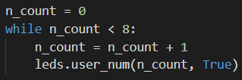 | - 0  - 1  - 7  - 8
If the ‘bots sensors 2 and 3 are detecting a line, what is the value of “detected”?  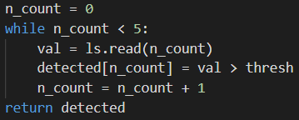 | - detected = [0, 1, 2, 3, 4]  - detected = [False, True, True, False, False]  - detected = [False, False, True, True, False]  - detected = [0, 0, 1, 1, 1]
What is the data type of:  x = 0.15 | - int  - float  - list  - tuple
What is the data type of:  x = [0, 1, 1, 0, 0] | - int  - float  - list  - tuple
What is the data type of:  x = 0 | - int  - float  - list  - tuple
What is the data type of:  x = (True, True) | - int  - float  - list  - tuple
What code accesses a single value from a list or tuple? | - vals  - vals(1)  - vals[1]  - vals = (0, 1)
What will be printed on the console?  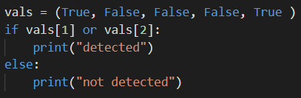 | - Detected  - Not detected  - Detected followed by not detected  - An error occurs
What does the highlighted code do?  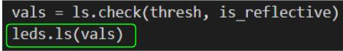 | - Turns on the one LED at index “vals”  - Uses the tuple “vals” to turn on or off line sensor LEDs  - Assigns a True value to “vals” for each LED that is on  - Causes an error
What is the value of x?  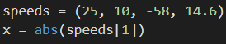 | - 25  - -25  - 10  - -10
What is the value of x?  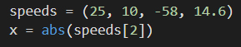 | - 25  - 10  - 58  - 14.6
What is the value of x?  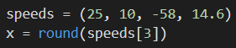 | - 58  - 14.6  - 14  - 15
What is returned by the function “prox.detect()”? | - A tuple of 0 or 1  - True or False  - A tuple of two Boolean values  - An integer between 0 and 4095
RIGHT is assigned what value? | - 0  - 1  - True  - False
What is the purpose of “prox.range()”? | - Determine the lowest threshold needed to detect a reflection  - Determine the lowest power needed to detect a reflection  - Determine if an object is in front of the CodeBot  - Move the CodeBot a specified distance
What is the final value of “det”?  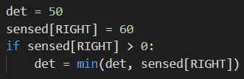 | - 50  - 60  - 0  - True
What line of code is needed when updating a global variable in a function? | - local power  - global power  - power = True  - power global
What is the lowest value that can be assigned to “power” when the while loop ends?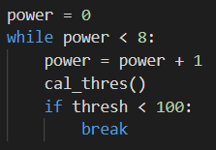 | - 0  - 1  - 8  - 100
What is the final value of “go_motors”?  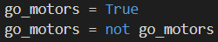 | - True  - False  - No  - An error occurs

